Practical 4
Aim: Implement a program for evaluation of postfix expression using stack.
Theory
The compiler finds it convenient to evaluate an expression in its postfix form. The virtues of postfix form include elimination of parentheses which signify priority of evaluation and the elimination of the need to observe rules of hierarchy, precedence and associativity during evaluation of the expression.
As Postfix expression is without parenthesis and can be evaluated as two operands and an operator at a time, this becomes easier for the compiler and the computer to handle.
Evaluation rule of a Postfix Expression states:
- While reading the expression from left to right, push the element in the stack if it is an operand.
- Pop the two operands from the stack, if the element is an operator and then evaluate it.
- Push back the result of the evaluation. Repeat it till the end of the expression.
Algorithm
1) Add ( to postfix expression.
2) Read postfix expression Left to Right until ) encountered
3) If operand is encountered, push it onto Stack
[End If]
4) If operator is encountered, Pop two elements
i) A -> Top element
ii) B-> Next to Top element
iii) Evaluate B operator A
push B operator A onto Stack
5) Set result = pop
6) END
Let's see an example to better understand the algorithm:
Expression: 456*+
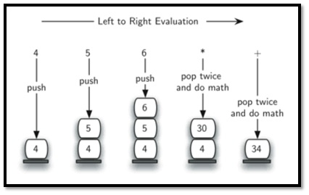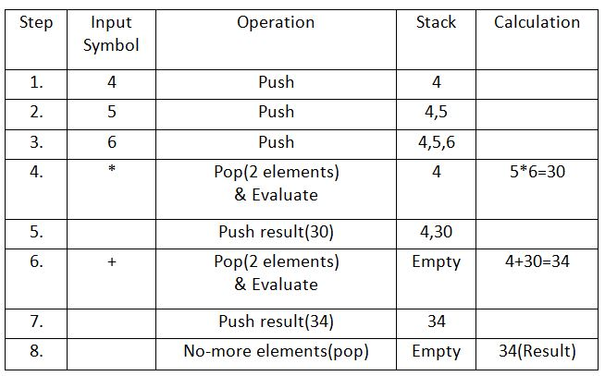

/*PracticalNo.04
Title: Write a program for evaluation of postfix expression using stack.
*/

#include<stdio.h>
#include<conio.h>
#include<math.h>
struct stack
{
int top;
int operand[20];
};
void push(struct stack*,int);
void pop(struct stack*);
void main()
{
struct stack s;
char str1[40];
int i=0, result, op1, op2;
s.top=-1;
printf(“Enter an expression in postfix form:\n”);
while((str1[i]=getchar())!=’\n’)
{
if(isdigit(str1[i]))
{
push(&s,str1[i]-‘0’);
}
else
{
op2=s.operand[s.top];
pop(&s);
op1=s.operand[s.top];
pop(&s);
switch(str1[i])
{
case’+’: result=op1+op2;
break;
case’-‘: result=op1-op2;
break;
case’*’: result=op1*op2;
break;
case’/’: result=op1/op2;
break;
}
printf(“\n Intermediate result=%d”, result);
push(&s, result);
}
i++;
}
printf(“\n The value of expression=%d”, result);
getch();
}
void push(struct stack*ps, int n)
{
ps->top++;
ps->operand[ps->top]=n;
}
void pop(struct stack* ps)
{
ps->top--;
}

OUTPUT:

Enter an expression in postfix form:35+42-*

Intermediate result=8 Intermediate result=2 Intermediateresult=16
Thevalueofexpression=16

Practical 5
Aim: Write a program to convert infix expression to postfix.
Theory

Infix, Prefix and Postfix are notations used for representing an expression. Each notation, bears the equivalence of the same expression written in a different manner. It is fairly simple to convert from one notation to the other using stack data structure. Depending on the position of operators and operands, there are three types of notations or ways of writing an expression containing operators, operands, and brackets - Infix Notation, Postfix Notation, and Prefix Notation. While infix notation is easier to read for us, postfix is easier to evaluate for a machine, such as in a calculator. This is because in a postfix operation operators are evaluated from left to right in a serial manner, which eliminates the need for brackets and omits any confusion regarding operator precedence. We will learn about them in more detail, in the upcoming sections. Infix notation is the notation in which operators come between the required operands. It is the same as the arithmetic notation that we had learned in our school days.

Syntax of infix notation
The syntax of infix notation is X op Y.
Example - If we were to add two numbers 3 and 4, the operator that is '+' would come between the operands 3 and 4. So the infix notation will be 3 + 4.
Postfix Expression, also known as Reverse Polish Notation is the type of notation in which operator comes after the operand. For eg- If the infix expression is x + y, it's corresponding postfix notation is x y + . We will exlore in details the conversion of infix to postfix expressions.
Postfix expression is considered better than the infix expressions, as postfix expressions are easier to evaluate and also they don't have overhead of brackets.

conversion from infix to postfix expression
- If we have an opening parenthesis "(", we push it into the stack.
- If we have an operand, we append it to our postfix expression.
- If we have a closing parenthesis ")" we keep popping out elements from the top of the stack and append them to our postfix expression until we encounter an opening parenthesis. We pop out the left parenthesis without appending it.
- If we encounter an operator:-
4.1. If the operator has higher precedence than the one on top of the stack (We can compare ), we push it in the stack.
4.2. If the operator has lower or equal precedence than the one on top of the stack, we keep popping out and appending it to the postfix expression.
- When the last token of infix expression has been scanned, we pop the remaining elements from stack and append them to our postfix expression.*

Infix expression: K + L - M*N + (O^P) * W/U/V * T + Q
Let us dry run the above infix expression and find out its corresponding postfix expression.
The above string is parsed from left to right. For each token, the elements in the stack as well as the corresponding postfix expression up to that point is shown using the table below:
Element | Stack contents | Postfix Expression
K |  | K
+ | +
L | + | K L
- | - | K L +
M | - | K L + M
* | -* | K L + M
N | -* | K L + M N
+ | + | K L + M N * -
( | + ( | K L + M N * -
O | + ( ^ | K L + M N * - O
^ | + ( ^ | K L + M N * - O
P | + ( ^ | K L + M N * - O P
) | + | K L + M N * - O P ^
* | + * | K L + M N* - O P ^
W | + * | K L + M N* - O P ^ W
/ | + / | K L + M N* - O P ^ W *
U | + / | K L + M N* - O P ^W * U
/ | + / | K L + M N* - O P ^W * U /
V | + / | K L + M N* - O P ^ W * U / V
* | + * | K L + M N* - O P ^W * U / V /
T | + * | K L + M N* - O P ^W * U / V / T
+ | + | K L + M N* - O P ^W * U / V / T * +
Q | + | K L + M N* - O P ^W * U / V / T * + Q
 |  | K L + M N* - O P ^W * U / V / T * + Q+
The final postfix expression is 𝐾𝐿+𝑀𝑁∗−𝑂𝑃𝑊∗𝑈/𝑉/𝑇∗+𝑄+KL+MN∗−OPW∗U/V/T∗+Q+
Explanation of the above table:
At step 1, since we have an operand (K), we are appending it our postfix operation. Then we encounter an operator(+), and check that our stack is empty. We push the operator in our stack. Next, we encounter another operand (L), and append it to our postfix operation. Now after step 3, our postfix expression contains KL, and stack contains +. The next element is (-), and we check that top of stack contains +, which holds equal precedence as (-). Thus we pop out (+), and append it our expression, which now looks like KL+. Since the stack is empty, (-) goes inside the stack. We continue this till the last element of our infix expression. To understand why an element is being added to the postfix expression or the stack, or popped out from the stack, refer to the rules for conversion discussed in the previous section.

/*PracticalNo05
Title: Write a program to convert infix expression to postfix.
*/

#include<stdio.h>
#include<string.h>char stack[50];
int top=-1;
void post(char infix[]);
void push(char);
char pop();
int main()
{
Char infix[25];
printf("\nENTER THE INFIX EXPRESSION=");
gets(infix);post(infix);
}

Void push(char symb)
{
if(top>=49)
{

}
else
{

}
}
printf("\nSTACK OVERFLOW");
return;

top=top+1;
stack[top]=symb;

char pop()
{
Char item;
if(top==-1)
{

}
else
{

}
printf("\nSTACK IS EMPTY");
return(0);

item=stack[top];top--;

return(item);
}
int preced(char ch)
{
if(ch==47)
{
return(5);
}

else if(ch==42)
{
return(4);
}
else if(ch==43)
{
return(3);
}
else
return(2);
}

void post(char infix[])
{
int l;
int index=0,pos=0;
char symbol,temp;
char postfix[40];
l=strlen(infix);
push('#');
while(index<l)
{
symbol=infix[index];switch(symbol)
{
case '(':
push(symbol);
break;
case')':
temp=pop();
while(temp!='(')
{

}
break;
postfix[pos]=temp;pos++;
temp=pop();

case'+':
case'-':
case'*':
case'/':
case '^':
while(preced(stack[top])>=preced(symbol))
{
temp=pop();postfix[pos]=temp;pos++;
}

}
index++;
}
push(symbol);break;
default: postfix[pos++]=symbol;
break;

while(top>0)
{
temp=pop();
postfix[pos++]=temp;
}
postfix[pos++]='\0';puts(postfix);return;
}

OUTPUT:
ENTER THE INFIX EXPRESSION=(a+b)*c
ab+c*

Practical 6
Aim: Write a program to implement operations on singly linked list
Theory
Linked List In C is a linear data structure consisting of nodes. Each node in a linked list is divided into two sections that hold data and the address of the successive node, stored at the random address in the memory.
Arrays are stored contiguously in the memory; when the given array size is large and the consecutive memory is unavailable to store array elements, we can not use an array in that case. Linked list overcomes this problem. where data can be stored at random locations and easily accessed by which they are linked together.

Basic Operations in Linked List
When it comes to linked lists, there are five operations supported by the series or list.
- Traversal – Through this operation, we can access all elements in the link list.
- Insertion – In this operation, elements can be added at the starting of the list.
- Deletion – In this operation, elements can be deleted at the starting of the list.
- Search – Through this operation, we can easily search for an element utilising the provided key.
- Sort – Through this operation, we can sort the nodes of the linked list.

Linked List - Insertion Operation
Adding a new node in linked list is a more than one step activity. We shall learn this with diagrams here. First, create a node using the same structure and find the location where it has to be inserted.
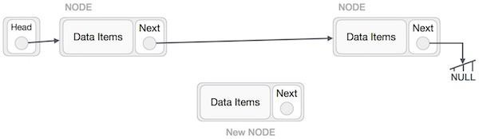
Imagine that we are inserting a node B (NewNode), between A (LeftNode) and C (RightNode). Then point B.next to C −
NewNode.next -> RightNode;
It should look like this −
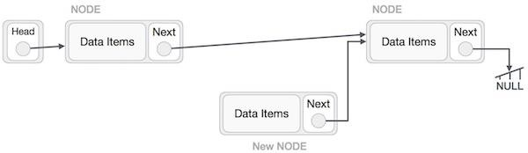
Now, the next node at the left should point to the new node.
LeftNode.next -> NewNode;
This will put the new node in the middle of the two. The new list should look like this −
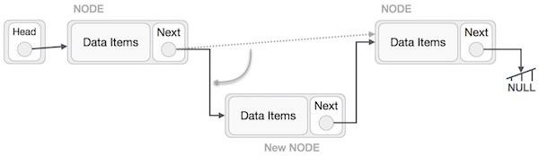
Insertion in linked list can be done in three different ways. They are explained as follows −
Insertion at Beginning
In this operation, we are adding an element at the beginning of the list.
Algorithm
1. START
2. Create a node to store the data
3. Check if the list is empty
4. If the list is empty, add the data to the node and
assign the head pointer to it.
5. If the list is not empty, add the data to a node and link to the
current head. Assign the head to the newly added node.
6. END
Linked List - Deletion Operation
Deletion is also a more than one step process. We shall learn with pictorial representation. First, locate the target node to be removed, by using searching algorithms.
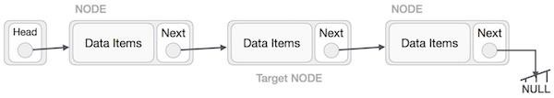
The left (previous) node of the target node now should point to the next node of the target node −
LeftNode.next -> TargetNode.next;
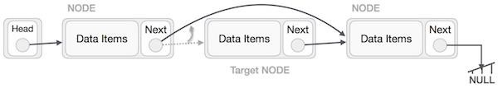
This will remove the link that was pointing to the target node. Now, using the following code, we will remove what the target node is pointing at.
TargetNode.next -> NULL;

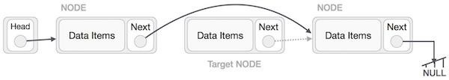
We need to use the deleted node. We can keep that in memory otherwise we can simply deallocate memory and wipe off the target node completely.
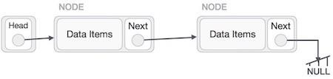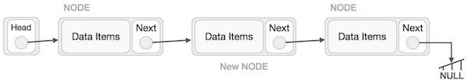
Similar steps should be taken if the node is being inserted at the beginning of the list. While inserting it at the end, the second last node of the list should point to the new node and the new node will point to NULL.

//Practical 5
// C Program to create a Linked List
#include <stdio.h>
#include <stdlib.h>

// Define the structure of Node
typedef struct Node {
int data;
struct Node *next;
} Node;

// A function that creates a new node and returns the
// pointer to it
Node *createNode(int data)
{
Node *newNode = (Node *)malloc(sizeof(Node));
newNode->data = data;

// Initially assigning the next pointer to NULL
newNode->next = NULL;

return newNode;
}

int main() {
Node *first = createNode(10);
// This will create: 10 -> 20 -> NULL
first->next = createNode(20);

// This will create: 10 -> 20 -> 30 -> NULL
first->next->next = createNode(30);

printf("Linked List: ");
Node *temp = first;
while (temp)
{
printf("%d ", temp->data);
temp = temp->next;
}
return 0;
}

Output
Linked List: 10 20 30

